View - Assignment
Create a View for employee table to get the salary if it is <10000 mark it as 'LOW' otherwise 'MODERATE' in separate column 'Sal_Status'. So the result of view should display the following details like EmpID, EmpName, Salary, Sal_Status.
Copied from MySQL:
use employees;
create table Employee(
Emp_id int primary key,
Emp_name varchar(50),
Department varchar(50),
Salary decimal(10,2)

);
insert into Employee(Emp_id, Emp_name, Department, Salary) values
(01, 'Abhi', 'HR', 20000),
(02, 'Bindhu', 'Finance', 1000),
(03, 'Sid', 'IT', 1800),
(04, 'Naina', 'Marketing', 9000),
(05, 'Chinnu', 'HR', 9500),
(06, 'Ankith', 'IT', 24000),
(07, 'Anju', 'Finance', 90000);

select * from Employee; (1)

create view emp_salary_view as
select
Emp_id,
Emp_name,
Department,
Salary,
case
when Salary <10000 then 'Low' else 'Moderate'
end as Sal_Status from Employee;

select * from emp_salary_view; (2)

OUTPUT:
1.
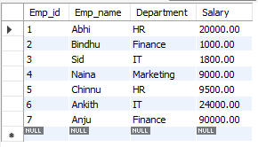

2.
